**OS LAB**

**Experiment 2**

**Nithin Jose**

**R4 46**

**Exercise 1**

**Send output of date command to already existing file.**

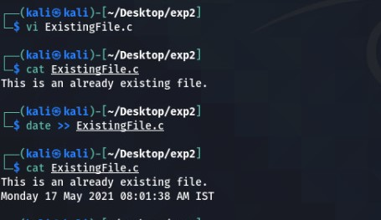

**Exercise 2**

**Encrypt the text in a file and display it**

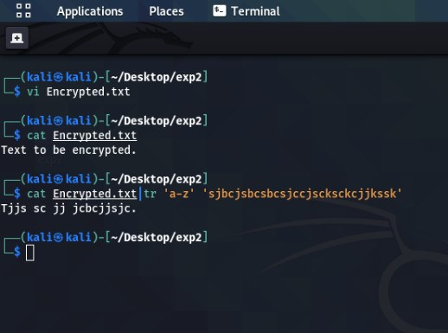

**Exercise 3**

**Create a file Sample and give 5 names in it.Display only the line that does not contain the character a but the result should be in reverse order.**

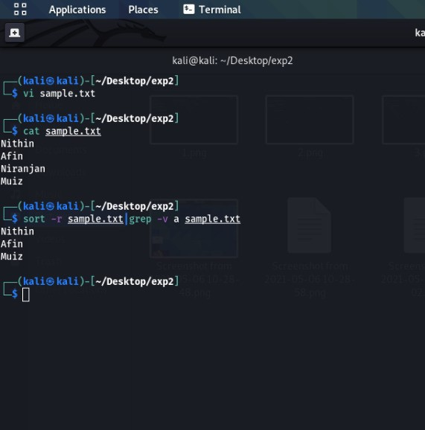

**Exercise 4**

**Write a command to give write and execute permission to a file.**

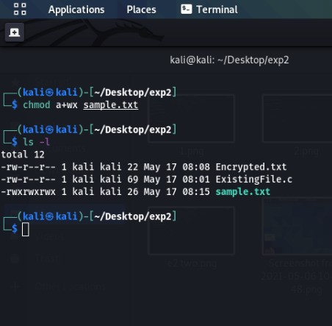

**Exercise 5**

**Write a code to show the currently running processes and their pid.**

